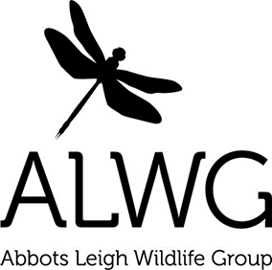
www.abbotsleighwildlife.com for updates and ways to get involved this month:
- Amphibians
- Ponds and Big Spawn Count
- Bird nesting
- Reporting Death and Disease in garden wildlife
- Help butterflies and moths
- Hedgehogs


Amphibians – the Toad Patrol team at Abbots Pool is out patrolling each evening during the amphibian migration and your help would be most welcome in ensuring that the pond is left undisturbed now. Please keep dogs out of the water, avoid pond dipping and please do not remove spawn from the water. Thanks!
Ponds and Big Spawn Count – the single most helpful thing you can do to encourage wildlife in your garden is to put in a pond https://tinyurl.com/hm97exm . Even a flat container of water, like a plant pot tray would be helpful to wildlife. The Big Spawn Count is being run again this year by the Freshwater Habitats Trust http://tinyurl.com/qyok4yw so do let ALWG know if you have amphibians/spawn in your garden pond this spring or if you see any around the village – photos are always welcome.
Bird nesting – remember that March to August is the main breeding season for nesting birds. Birds, their nests and eggs are all protected by the Wildlife and Countryside Act www.tinyurl.com/aedmu95 With many species in decline, our village trees and hedgerows are vital for both their food and shelter, so leave trimming until the winter now www.tinyurl.com/anckg2k Wildlife crime can be reported by phoning 101 (999 in an emergency), or emailing https://tinyurl.com/jsy6m74
Reporting Death and Disease in Garden Wildlife - we can all contribute to knowledge about the health of various species which visit our gardens. This will eventually lead to greater understanding of how we can help. To report death or illness in garden birds, amphibians, reptiles or hedgehogs, please visit the Garden Wildlife Health project www.gardenwildlifehealth.org

Help butterflies and moths – Butterfly Conservation has over a hundred suggestions for both foodplants for caterpillars and plants to encourage butterflies in your garden. Take stock of your garden as a carefully thought out garden with suitable, indigenous nectar plants can attract more than twenty species http://tinyurl.com/mp72von
Hedgehogs – as they emerge from hibernation, give our village hedgehogs a hand. Advice from BHPS is simple: check areas before strimming/mowing; check compost heaps before digging; stop using pesticides/poisons; ensure there is an easy route out of ponds/pools and make easy access into your garden so they can eat your slugs and snails… all that is needed is a 5” square gap between you and your neighbours’ gardens http://tinyurl.com/qgdgmaf

Thanks for getting involved .......................................................Tim Martin, Tom Walmsley, Cat Abel and Sarah Pitt
Check for events l Register for updates l Report interesting sightings
info@abbotsleighwildlife.com l www.abbotsleighwildlife.com l 07771 963504

