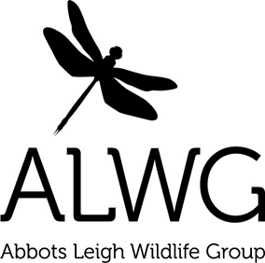
www.abbotsleighwildlife.com for updates and ways to get involved this month:
- Strimming..…beware!
- Say no to mow
- Look after that lawn
- Hedgehogs
- Ticks and Lyme disease
- Bird nesting and recording

- Baby birds
- Just add water
Strimming……beware – do take great care that wildlife is not harmed if you use a strimmer. Try to leave areas of your garden wild and lawn edges natural, allowing clover, daisies and dandelions to flower. Wildlife relies on leaf piles, compost heaps, long grass, nettles and brambles for egg laying, food or making a home in e.g.: our precious village froglets, toadlets and efts (young newts). Avoid causing distressing, often fatal injuries by strimming and leave space for wildlife instead http://tinyurl.com/jdegdbd
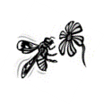
Say no to mow – instead of mowing, leave a patch of your lawn to its own devices during spring and summer. Some wildflowers will appear in your new mini-meadow, so then give the wildflowers a chance to complete their cycle of growing, flowering and setting seed. More info here https://tinyurl.com/yamdl6up
Look after that lawn – where you do mow, leave the lawn clippings as it saves on our green waste and also provides nutrients as the clippings will naturally begin to be absorbed after a couple of days encouraging thicker and healthier lawn growth. You’ll quickly notice a difference.
Hedgehogs – do let us know if you are lucky enough to see one of these creatures in your garden. They are in decline and need our help so please see what you can do https://tinyurl.com/zhfgcmj They should not be out in daytime however, so if you need advice call 07771 963504 or read http://tinyurl.com/zb3kn7h
Ticks and Lyme disease – Lyme disease is a bacterial infection spread to humans by infected ticks, tiny spider-like creatures found in woodland and heath areas that feed on the blood of birds/mammals. It can often be treated effectively if it's detected early on, so please be tick aware and take sensible precautions http://tinyurl.com/d6fkbqf
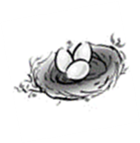
Bird nesting and recording – please remember that March to August is the main breeding season for nesting birds. Birds, their nests and eggs are protected by the Wildlife and Countryside Act www.tinyurl.com/aedmu95 With many species in decline, our village trees and hedgerows are vital for both their food and shelter, so leave trimming until the winter now www.tinyurl.com/anckg2k If you would like to help the nationwide data collection of birds, do join Birdtrack https://tinyurl.com/ydgg2ta9 and add your garden bird sightings each day. The site is easy to use.
Baby birds – help is at hand if you find a baby bird http://tinyurl.com/zafp5h9 or if you find a young Barn or Tawny Owl http://tinyurl.com/zbs4c9h
Just add water – why not add a pond and increase the wildlife in your garden? http://tinyurl.com/pz78mcw Remember to provide water for wildlife in your garden, especially during warm weather……even a flat container of water, like a plant pot tray or up-turned lid is helpful.
Thanks for getting involved .............................................................Tim Martin, Tom Walmsley, Cat Abel and Sarah Pitt
Check for events l Register for updates l Report interesting sightings
info@abbotsleighwildlife.com l www.abbotsleighwildlife.com l 07771 963504

