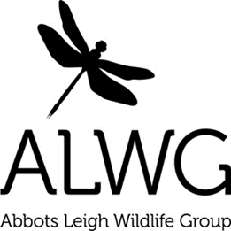
www.abbotsleighwildlife.com for updates and ways to get involved this month
- Help pollinators
- Keep your garden birds healthy
- Wildlife gardening
- Just add water

Help pollinators – you can increase the biodiversity in your garden by making a “bug hotel” to help these creatures survive the winter months http://tinyurl.com/qdqcny5 . Remember to plant some nectar-rich flowers or bulbs e.g. crocus, snowdrop and aconite to provide essential food for them. https://tinyurl.com/y8gm86yz Also leave patches of land to grow wild; cut grass less often; avoid disturbing or destroying nesting or hibernating insects; and think carefully about whether to use pesticides http://tinyurl.com/oh2pgbb

Keeping your garden birds healthy - good hygiene is particularly important in and around bird feeders. Wash and move feeding stations regularly. RSPB advice http://tinyurl.com/ob5da8j

Wildlife gardening - a wildlife garden doesn’t need to be messy or unattractive, simply including some of the following features could benefit wildlife: a bog garden or mini-pond; log piles and rockeries; reptile refuges; a variety of vegetation; wintering sites; a compost heap. There are lots of ideas here: http://tinyurl.com/obxron5 help create habitat for wildlife.

Just add water – the single most beneficial thing you can do for wildlife is to add a pond. There is a fantastic guide here http://www.froglife.org/info-advice/just-add-water/

Thanks for getting involved …………………………..……...........................Tim Martin, Tom Walmsley, Cat Abel and Sarah Pitt
Check for events l Register for updates l Report interesting sightings
info@abbotsleighwildlife.com l www.abbotsleighwildlife.com l 07771 963504

